Attestiv-TotalAgility Connector Pocket Guide

December 2024

Version 1.0

Contents (“UPDATE TABLE” after placing content)

Table of Contents

What is the Base64.ai TotalAgility Connector? 3

Technical Assets included in the Package 4

Package Contents 4

How do I download the Base64.ai KTA Connector from Marketplace? 4

How does the Base64.ai KTA Connector work? 4

Architecture of the Base64 Connector 5

Getting started 5

Why Kofax Marketplace? 6

Frequently Asked Questions? 6

Who do I need to contact to get the Base64.ai API private keys or user credentials? 8

**Who is Attestiv?**

# Attestiv is an AI-powered company specializing in the validation and authentication of digital media, including images, videos, and documents. Leveraging patented AI and blockchain technologies, the company ensures the integrity of digital assets by detecting tampering and identifying forgeries.

# Attestiv's platform includes advanced image analysis capabilities such as tamper scoring, deep scan pixel analysis, and media authentication. These features are designed to prevent fraud, reduce losses, and maintain trust across industries like insurance, financial services, and media.

# The company also offers APIs and a web-based dashboard for seamless integration into workflows, making their solutions accessible and scalable for organizations aiming to protect the authenticity of their visual content.

# What is the Attestiv - TotalAgility Connector?

The Attestiv TotalAgility Connector from Tungsten Automation Labs is a package that provides the assets you need to connect to Attestiv’s Image Analysis API. This Connector is designed to be easily installed and to get you up and running to test out a prepackaged process:

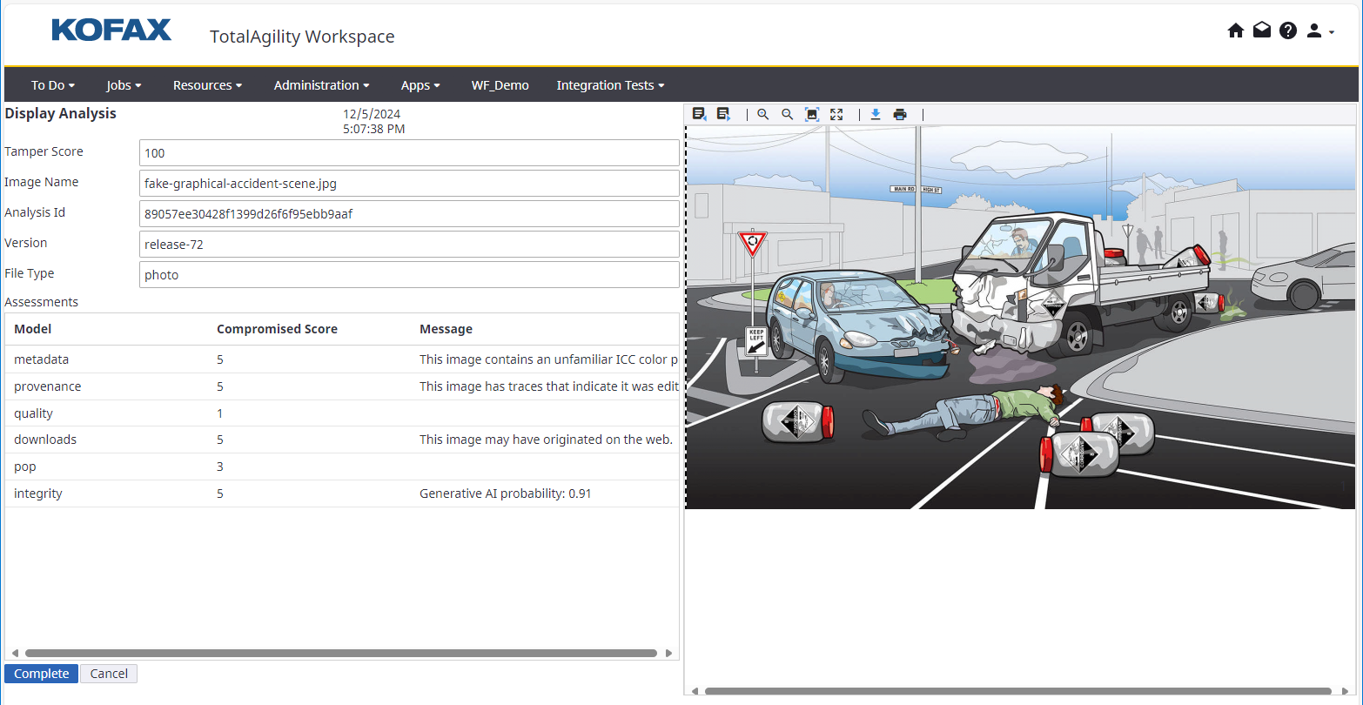

# Technical Assets included in the Package

The following items are contained in the Attestiv Connector TotalAgility Package.

## Package Contents

* Business Processes: The package will include 3 business processes:
  + POC_Attestiv_Image_Analysis_Bulk: A standalone process that shows how can multiple files can be analyzed at the same time using the Attestiv connector
  + POC_Attestiv_New_Request: A process which takes care of all new incoming requests by creating a new single image analysis request
  + POC Attestiv Image Analysis: A process which handles single-image analysis request against the Attestiv Image Analysis API..
* DLL: .NET Framework v4.8 DLL (tungstenlabs.integration.attestiv.dll) which performs all the necessary functions to communicate with Attestiv’s API and return the analysis information
* UX Forms: Used to run the demo that includes uploading a document and displaying the image tamper analysis results.

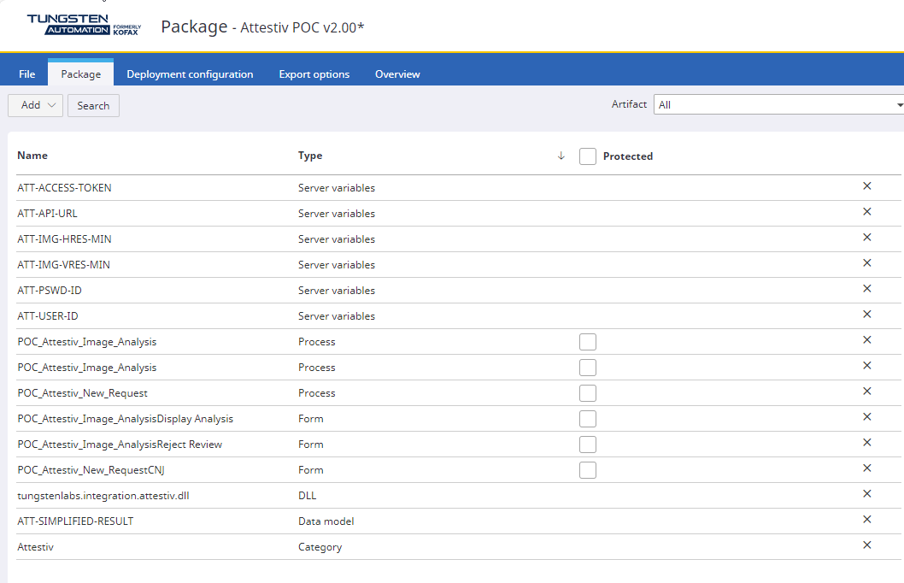

# How do I download the Attestiv TotalAgility Connector from Marketplace?

The solution is available at <TODO - put new URL here> and downloadable from Github <TODO - insert link here>. It comes with a detailed readme file which describes how to set up the solution in TotalAgility.

# How does the Attestiv TotalAgility Connector work?

The connector interacts with Attestiv’s Image Analysis API with the following steps:

1. Uploads the image file.
2. Waits for the image tamper analysis to complete & returns the raw JSON with the analysis information.
3. Include a method which simplifies the analysis results for display.

# Architecture of the Attestiv Connector

Tungsten Labs is also offering the source code for the connector, so it can be changed and adapted to your needs or to take advantage of Attestiv additional APIs (Video Analysis, etc).

The connector is written in C# .Net 4.8 (compatible with TotalAgility v7.6+), and it utilizes some external libraires which are merged into a single dll.

The library follows the best practices as published in Tungsten Automation’s “Building TotalAgility Connector” document.

# Getting started

To get started using the connector, please follow the steps below:

1. Follow the steps to import the Package to a TotalAgility instance.
   * Please check all components are imported as per the package manifest.
2. Obtain an Attestiv API Token - Visit the Attestiv website and sign-up.
3. Once you’re signed up, on the Attestiv main console, please browse to “Profile”, and under your user information, please get your token; we’re going to need this to use the connector later.
4. In your TotalAgility instance, please go to System Data -> Server Variable and locate the Attestiv ones.
   * ATT-USER-ID: Here you will put the main user ID for the API requests.
   * ATT-PSWD-ID: Here you will put the main user’s password for the API requests.
   * ATT-ACCESS-TOKEN: Here you will put the access token obtained from the Attestiv main console.
   * ATT-API-URL: URL for the Attestiv API (please confirm with your Attestiv account executive).
   * ATT-IMG-HRES-MIN: Minimum horizontal resolution for images (default is 640).
   * ATT-IMG-VRES-MIN: Minimum vertical resolution for images (default is 480).
5. To call the connector from your workflow item, create a .Net activity, and configure it like the following screenshot:

* 1. taDocID: The TotalAgility document instance ID for the document you want to submit
  2. taSessionID: Your TotalAgility session’s ID.
  3. taSdkUrl: The URL for the TotalAgility SDK instance you want to connect to get your document.
  4. Return Parameter: A string variable which will recive the resulting analysis JSON string.

1. Once the variable has been populated with the analysis results, you can either use it tocall the “ExtractResultTamperScore” method for a simplified version of the JSON, use it in an ordinary activity to display the raw results or do your post-processing.

# Why Tungsten Automation Marketplace?

Tungsten Automation Marketplace is a digital showcase of assets connecting customers with pre-built, integrated components and solutions to extend their digital workforce. The Attestiv TotalAgility Connector will be easily available in the Marketplace, built on top of Tungsten’s Intelligent Automation platform. It accelerates customer automation journeys and reduces the need for custom development work. The Tungsten Automation Marketplace also allows partners to expose their value-added solution to new prospects and customers.

# Frequently Asked Questions?

Below is the list of possible questions gathered to answer the basic questions about storage and extraction.

Storage

Is data stored in the cloud? And how long is it stored?

Yes. To ensure maximum system performance and support flexibility, the Attestiv service is offered primarily via the cloud and it is not intended as a long-term storage repository. Thus, uploaded images expire and are removed from the system after 30 days. Please review your Attestiv configuration for more information.

How do you secure the transfer of the data? and what happens after the document is uploaded to the server?

Data transfer is handled via secure TLS connection. Each user is authenticated using an token in the https header. Data is encrypted in transit and at rest. Transport Layer Security (TLS, protocol version 1.2) is utilized for encryption during transport. Attestiv & TotalAgility support high-grade 256-bit ciphers as well as ciphers providing forward secrecy. Once data reaches Attestiv, it is processed and stored in a client-specific object store on a 256-bit encrypted disk.

TODO – Attestiv Certifications

How many documents can the system process simultaneously?

The connector includes methods to handle single or bulk image analysis request. (TODO – Is there a max?)

Detection

What type of files does Attestiv support?

Presently, Attestiv can only analysis PNG and JPG files that are at least 640x480.

How long does it take to for the analysis to complete?

Depending on the number of files and size, it may take from a couple of seconds to a few minutes.

Are there any limits when it comes to the size of the files?

TODO – Ask Attestiv

TODO – Anything else??

TODO

## Who do I need to contact to get the Attestiv token and/or user credentials?

Please visit the Attestiv Website (https://attestiv.com) and sign-up; once you have your credentials registered, you can get your token from your user settings in the main console.

|  |  |
| --- | --- |
| **Key** | **Value** |
| ATT-API-URL | Base URL for Attestiv’s API calls |
| ATT-ACCESS-TOKEN | Access token obtained from your user setting in Attestiv’s main console site. |
| Do not change below, unless consulted or advised | |
| KTA_SDK_URL | Internal to KTA – URL for the KTA RESTful API SDK. |